**Chapter-8**

**System Implementation**

**8.1 Implementation.  
8.2 Basic Design Approach.**

**8. System Implementation**

**8.1 Implementation**

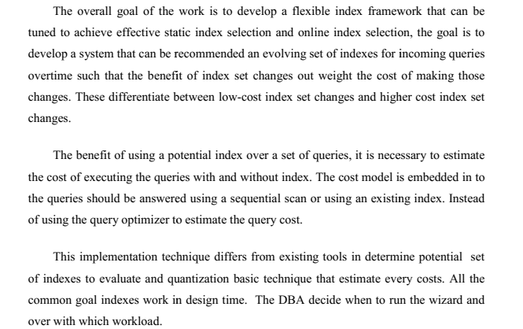

**8.2 Basic Design Approach**

